**SOFTWARE**

**REQUIREMENTS SPECIFICATION**

**For**

# Recipe Recommendation system

**Prepared by:-**

Naveen.R

Mahesh Boopathi.M

Udhya Raj Kumar.R

## 1. Introduction

### 1.1 Purpose

Many people often cook a dish with a cooking recipe on Websites and magazines. The listed ingredients in the recipe sometimes cannot be prepared. This paper proposes a recommendation system for alternative ingredients. We are using JAVA and MYSQL to design the whole system interface (UI). Through the UI we can understand the user's preferences and his/her daily amount of nutrients that can be ingested. Based on the user preference the system can extract from the knowledge base in line with a number of sample recipes for recommendation.

### 1.2 Propose System

In Proposed system we analysing the Android application .So, in that the user can register the application then registration is successful then login the application. As well as Admin can register the application then registration is successful then login application. After login User can upload recipe image. Then this image is display in Admin dashboard. Then admin after login View this image and substantiate the image. Then user can Add new recipe and also give rate as well as again view this recipe.

### 1.3 Glossary

|  |  |
| --- | --- |
| TERM | DEFINITION |
| User | People who search recipes and recommended it. |
| Admin | Person who can manage the all system and can add recipes. |
| System | Recommends recipes based on what they prefer to the user |
| Database | Location of all recipes, ingredients, user’s information, rates on this system. |
| Website | A website where the user searches for recipes and receives recipe suggestions. |
| Recommendation System | It is a system that offers suggestions for the user based on past purchases, searches, or behaviors of other users. |

### 2.1 SYSTEM ARCHITECTURE

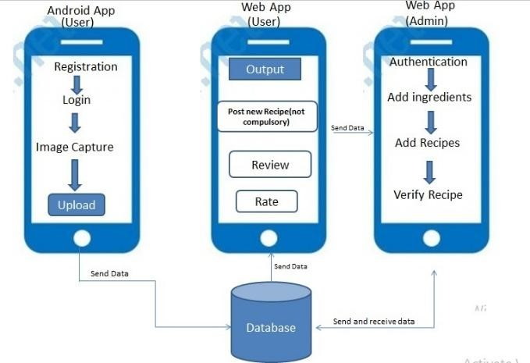

There system is divided into three parts according to functions performed by individuals. In this system we need to collect the data from different resources like recipes, ingredients, nutrition values for different recipes so that we are divide the system in two subsections:-

1. Admin:-Admin part manages all data related to recipe like add recipe delete recipe, manage ingredients. Admin need to perform the verification of recipes posted by the user with some basic user management functions.

2 .User:- User needs to authenticate with system and upload different images from application. The uploaded image will be displayed on webpage and system identifies the ingredients from the Image and suggest recipe according to ingredients.

### 2.2 OVERALL DESCRIPTION

Entity Relationship Diagram of recipe recommendation system

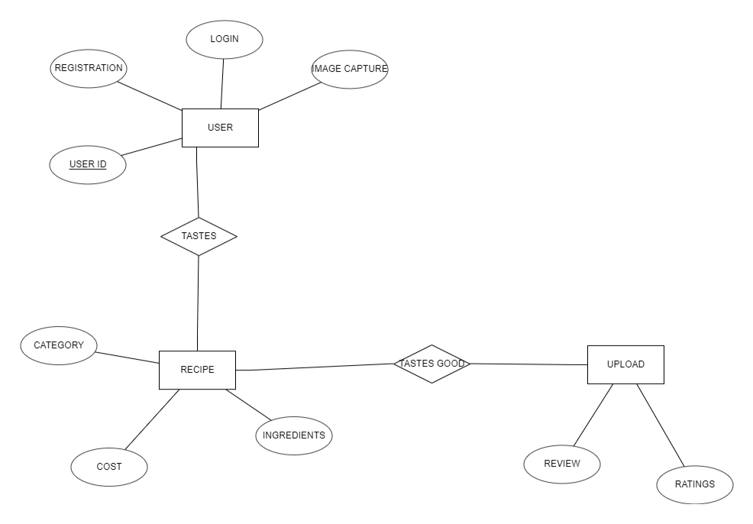

**2.3 case diagram for recipe recommendation system**

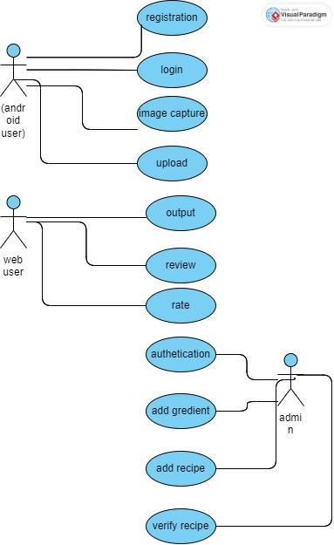

**2.4 class diagram**

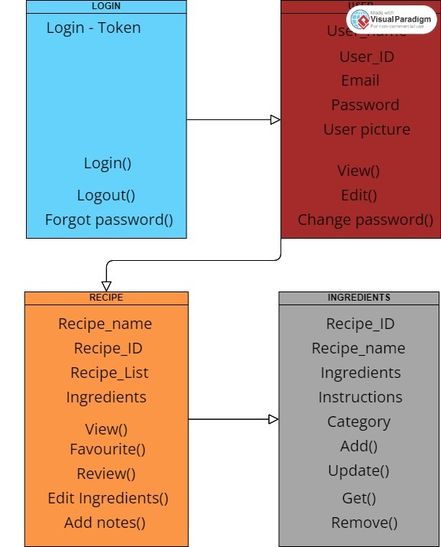

**2.4 Conclusion**

Software requirements document is an important document of project. We explained how we will do the project in this document. This software requirements document describes in detail the functional and non-functional requirements and the interface requirements of the system.